BUILDWISE – HOUSE CONSTRUCTION MANAGEMENT SYSTEM USING ZOHO CREATOR

A PROJECT REPORT

Submitted by
KARTHIK R
(240701232)

in partial fulfilment of the End Semester Examination for the course
CB23F35 –
LOW-CODE APPLICATION DEVELOPMENT USING ZOHO CREATOR
in
BACHELOR OF ENGINEERING
COMPUTER SCIENCE AND ENGINEERING


RAJALAKSHMI ENGINEERING COLLEGE
(An Autonomous Institution, Affiliated to Anna University, Chennai) Rajalakshmi Nagar, Thandalam, Tamil Nadu – 602 105
NOVEMBER 2026

RAJALAKSHMI ENGINEERING COLLEGE
(An Autonomous Institution, Affiliated to Anna University, Chennai)

BONAFIDE CERTIFICATE

Certified that this project report titled “BuildWise – House Construction Management System” is the bonafide work of KARTHIK R (240701232), who carried out the individual project work on the Zoho Creator low-code platform for the course CB23F35 – Low-Code Application Development using Zoho Creator, during the academic year 2026–2027, Semester V, under my supervision.

SIGNATURE

Dr.J. JINU SOPHIA
Associate Professor / Course Faculty Department of Computer Science And Engineering
Rajalakshmi Engineering College

Submitted for the End Semester Examination (Individual Project) held on

.

INTERNAL EXAMINER EXTERNAL EXAMINER

Abstract
House construction involves many activities that run at the same time: scheduling of work, purchase of materials, payment of labour, handling of problems on site and storage of drawings and contact details. In small and medium residential projects these activities are commonly recorded in notebooks, messages and separate spreadsheets, which makes it difficult for the owner, engineer, contractor and supervisor to see the true state of a project.
Expenses may cross the planned budget without notice, wages are calculated by hand, and issues or delays reach the responsible person late. BuildWise – House Construction Management System is a low-code application developed on Zoho Creator to bring these activities into one platform. Zoho Creator was chosen because forms, reports, pages and workflows can be configured visually, while Deluge scripting handles the specific business rules. The application contains seven forms: Project Details, Construction Work Tracker, Expense Tracker, Attendance and Salary, Issue and Delay Manager, House Plans Documents and Project Members Contacts.
Each form has a corresponding report, and the BuildWise Home Dashboard gives a centralised overview. Deluge workflows calculate wages from attendance, compare total expenses with the estimated project budget and display a warning when it is exceeded, set the work status from the completion percentage, and send email notifications for new issues, expense updates and resolved issues. A scheduled reminder for upcoming work deadlines is provided, while an overdue work alert is identified as a planned enhancement. Access is organised for five roles: Owner, Engineer, Contractor, Supervisor and Labourer. The report presents the requirements, design, implementation, test cases, deployment considerations and limitations of the application. Test results, screenshots and deployment details that were not available while preparing the report are marked as placeholders, and no performance or productivity improvement is claimed. The project shows that a practical construction management tool can be built with visual configuration and a small amount of scripting, and it identifies integrations, mobile use and richer analytics as future work.
Keywords: House Construction Management; Zoho Creator; Deluge Scripting; Workflow Automation; Role-Based Access Control; Construction Management

Project at a Glance

Attribute | Details
Project Title | BuildWise – House Construction Management System
Application Domain | Construction project management (residential house construction)
Student Name and Register No. | Sameer Ahamed S – 241801241
Programme | B.Tech, Artificial Intelligence and Data Science
Study details | Semester V | Academic year 2026–2027
Course | CB23F35 – Low-Code Application Development using Zoho Creator
Zoho Creator Edition | Professional (trial access used for the course)
Application Name (Link Name) | BuildWise (link name: buildwise-house-construction-management-app)
Published / Live URL | https://creatorapp.zoho.in/sameerahamed.s.2024.aids1441/build wise-house-construction-management-app
Demo Credentials (per role) | Owner: demo.owner@example.com | Engineer: demo.engineer@example.com | Contractor: demo.contractor@example.com | Supervisor: demo.supervisor@example.com | Labourer: demo.labourer@example.com (passwords supplied separately to the evaluator)
Number of Forms / Subforms | 7 / 0 – no subform used; forms are related through lookup fields
Number of Reports (by type) | 7 (one for each form) – all seven are List reports
Number of Pages / Dashboards | 1 – BuildWise Home Dashboard
Number of Workflows | 8 automations: 7 implemented, 1 planned (Overdue Work Alert) – 6 form workflows and 1 schedule workflow (Upcoming Work Deadline Reminder)
Deluge Functions / Custom Actions | None – the Deluge logic is written inline in the form and schedule workflows; no separate functions or custom actions are defined
Integrations | None. Email notifications sent through Deluge workflows; no other Zoho products or external APIs
Roles and Profiles Defined | 5 roles: Owner, Engineer, Contractor, Supervisor, Labourer
Environments Used | Development and Production (Stage not used)
Date of Production Deployment | 1 November 2026

Table of Contents

Chapter | Title / Section | Page No.
 | Abstract | ii
 | Acknowledgement | iii
 | Project at a Glance | iv
 | List of Tables | vii
 | List of Figures | viii
 | List of Abbreviations | ix
1 | Introduction | 1
1.1 | Background | 1
1.2 | Problem Statement | 1
1.3 | Objectives | 1
1.4 | Scope of the Project | 2
1.5 | Justification for a Low-Code Approach | 2
1.6 | Organisation of the Report | 3
2 | Requirement Analysis | 4
2.1 | Stakeholders and User Roles | 4
2.2 | Functional Requirements | 4
2.3 | Non-Functional Requirements | 5
2.4 | Hardware and Software Requirements | 6
2.5 | Use Case Model | 6
3 | System Design | 8
3.1 | System Architecture | 8
3.2 | Data Model | 8
3.3 | Form Design | 9
3.4 | Process and Workflow Design | 12
3.5 | User Interface and Navigation Design | 15
3.6 | Access Control Design | 15
4 | Implementation | 17
4.1 | Application Setup | 17
4.2 | Forms and Data Capture | 17
4.3 | Reports | 20
4.4 | Pages and Dashboards | 21
4.5 | Deluge Scripting | 21
4.6 | Workflows and Automation | 23
4.7 | Integrations | 25
4.8 | User Management and Role-Based Access | 26
4.9 | AI and Analytics Features | 26
4.10 | Pro-Code Extension | 26
4.11 | Mobile and Portal Access | 26
5 | Testing and Debugging | 27

Chapter | Title / Section | Page No.
5.1 | Testing Strategy | 27
5.2 | Test Cases | 27
5.3 | Debugging Deluge Scripts | 28
5.4 | Defect Log | 29
5.5 | User Acceptance Testing | 29
6 | Deployment, Security and Governance | 30
6.1 | Environments and Deployment Strategy | 30
6.2 | Performance Optimisation | 30
6.3 | Security Features | 31
6.4 | Governance and Administration | 31
7 | Results and Discussion | 32
7.1 | Application Output | 32
7.2 | Achievement of Objectives | 33
7.3 | Comparison with the Existing System | 33
7.4 | Limitations of the Low-Code Approach | 34
7.5 | Reflection on the No-Code to Low-Code to Pro-Code Spectrum | 34
8 | Conclusion and Future Enhancements | 35
8.1 | Conclusion | 35
8.2 | Future Enhancements | 35
8.3 | Learning Outcomes and Career Relevance | 35
 | References | 35
Appendix A | Zoho Creator Feature Coverage Checklist | 36
Appendix B | Complete Deluge Source Code | 37

List of Tables

Table Number | Title | Page No.
Table 2.1 | Stakeholders and user roles | 4
Table 2.2 | Functional requirements | 4
Table 2.3 | Non-functional requirements | 5
Table 2.4 | Hardware and software requirements | 6
Table 2.5 | Use case description – Record attendance and calculate wage | 6
Table 2.6 | Use case description – Record an expense and check the project budget | 7
Table 2.7 | Use case description – Report an issue and notify the project owner | 7
Table 3.1 | Entities and relationships | 9
Table 3.2 | Field specification – Project Details form | 10
Table 3.3 | Field specification – Construction Work Tracker form | 10
Table 3.4 | Field specification – Expense Tracker form | 11
Table 3.5 | Field specification – Attendance and Salary form | 11
Table 3.6 | Field specification – Issue and Delay Manager form | 11
Table 3.7 | Field specification – House Plans Documents form | 12
Table 3.8 | Field specification – Project Members Contacts form | 12
Table 3.9 | Role–permission matrix (design intent) | 16
Table 4.1 | Forms and their purpose | 17
Table 4.2 | Reports implemented | 20
Table 4.3 | Deluge scripts implemented | 22
Table 4.4 | Workflows and automation | 23
Table 4.5 | Integrations and outbound communication | 26
Table 5.1 | Test cases | 27
Table 5.2 | Defect log | 29
Table 5.3 | User acceptance feedback | 29
Table 6.1 | Deployment checklist | 30
Table 6.2 | Performance considerations | 30
Table 6.3 | Security controls | 31
Table 7.1 | Mapping of objectives to outcomes | 33
Table 7.2 | Manual approach versus BuildWise | 33
Table A.1 | Feature coverage checklist | 36

List of Figures

Figure Number | Title | Page No.
Figure 2.1 | Use case diagram of BuildWise | 6
Figure 3.1 | System architecture of BuildWise | 8
Figure 3.2 | Entity–relationship diagram of BuildWise | 9
Figure 3.3 | Level 0 data flow diagram of BuildWise | 12
Figure 3.4 | Level 1 data flow diagram of BuildWise | 13
Figure 3.5 | Process flow for automatic wage calculation | 13
Figure 3.6 | Process flow for the project budget alert | 14
Figure 3.7 | Process flow for work status automation | 14
Figure 3.8 | Process flow for email notification workflows | 14
Figure 3.9 | Process flow for deadline reminder and planned overdue alert | 15
Figure 3.10 | Navigation structure of BuildWise | 15
Figure 4.1 | BuildWise home page and navigation sections | 17
Figure 4.2 | Project Details form in live mode | 18
Figure 4.3 | Construction Work Tracker form in live mode | 18
Figure 4.4 | Expense Tracker form in live mode | 19
Figure 4.5 | Attendance and Salary form in live mode | 19
Figure 4.6 | Issue and Delay Manager form in live mode | 19
Figure 4.7 | House Plans Documents form in live mode | 20
Figure 4.8 | Project Members Contacts form in live mode | 20
Figure 4.9 | Representative report of BuildWise | 21
Figure 4.10 | BuildWise Home Dashboard | 21
Figure 4.11 | Workflow configuration in Zoho Creator | 25
Figure 4.12 | Roles and permission profiles configuration | 26
Figure 5.1 | Deluge debug output or log | 29
Figure 6.1 | Environments and publishing | 30
Figure 6.2 | Audit trail or administration settings | 31
Figure 7.1 | Scenario step 1 – project, members and plans | 32
Figure 7.2 | Scenario step 2 – work progress and wage calculation | 32
Figure 7.3 | Scenario step 3 – budget warning and notifications | 32
Figure 7.4 | Scenario step 4 – dashboard and reports | 33

List of Abbreviations

Abbreviation | Expansion
AI | Artificial Intelligence
API | Application Programming Interface
CRUD | Create, Read, Update, Delete
DFD | Data Flow Diagram
ER | Entity–Relationship
FR | Functional Requirement
ID | Identifier
NFR | Non-Functional Requirement
RBAC | Role-Based Access Control
REST | Representational State Transfer
UAT | User Acceptance Testing
UI | User Interface
URL | Uniform Resource Locator
Zia | Zoho’s AI assistant

  - Background
Chapter 1
Introduction

A house construction project brings together many activities that must be coordinated over several months. The owner has to decide and control the budget, the engineer prepares and interprets drawings, the contractor arranges materials and labour, the supervisor watches the daily progress on site, and the labourers carry out the work. Each of these persons produces information: work schedules, bills and payments, attendance of labourers, problems found on site, plan drawings and contact details of the people involved.
In many small and medium residential projects this information is kept in notebooks, mobile phone messages, paper registers and separate spreadsheets. Because the records are scattered, the owner cannot easily say how much has been spent against the estimate, which activities are late, or whether a problem reported on site has been attended to. Manual calculation of daily wages and manual follow-up of deadlines add to the effort and to the chance of error.
Low-code platforms allow business applications to be assembled from visual building blocks, with a limited amount of scripting for the rules that are specific to the problem [1]. Zoho Creator is one such platform, in which forms, reports, pages and workflows are configured in a browser and extended with the Deluge scripting language [2]. BuildWise – House Construction Management System was developed on Zoho Creator for the course CB23F35 – Low-Code Application Development using Zoho Creator. It provides a single, web-based place to record and monitor the activities of a house construction project.
  - Problem Statement
House construction projects generate financial, labour, schedule and document records that are normally maintained in different places and in different formats. As a result, the project team lacks a consistent, up-to-date view of the project and depends on manual calculation and personal communication to detect budget overruns, delays and unresolved site problems. A centralised, role-aware application is needed that records these details once, applies the calculation rules automatically and informs the responsible people when attention is required. The main pain points are listed below.
    - Expenses are recorded in several places, so the total spent is not compared with the estimated budget until late in the project.
    - Daily wages are calculated manually from attendance, which is time-consuming and error-prone.
    - The progress of each construction activity is updated by hand, and the status of the activity may not match its actual completion.
    - Issues and delays reported on site reach the responsible persons late because there is no automatic notification.
    - House plans, documents and contact details of project members are not stored together with the project they belong to.
  - Objectives
The objectives of the project are as follows.
    - O1. To design and build seven connected forms that capture project details, construction work, expenses, attendance and salary, issues and delays, house plan documents and project member contacts.

    - O2. To automate the calculation of wages from attendance and the updating of work status from completion percentage using Deluge scripting.
    - O3. To monitor total expenses against the estimated project budget and display a warning when the budget is exceeded.
    - O4. To send email notifications for new issues, expense record updates and resolved issues, and to remind users of upcoming work deadlines through a scheduled workflow.
    - O5. To provide a report for each form and a BuildWise Home Dashboard that gives a centralised overview of the project.
    - O6. To organise access for five user roles – Owner, Engineer, Contractor, Supervisor and Labourer – through role-based access control.
  - Scope of the Project
The scope of BuildWise covers web-based recording and monitoring of the activities of a house construction project. The following items are within the scope of the implemented application.
    - Seven forms: Project Details, Construction Work Tracker, Expense Tracker, Attendance and Salary, Issue and Delay Manager, House Plans Documents and Project Members Contacts.
    - A report corresponding to each of the seven forms and a BuildWise Home Dashboard.
    - Automation through Deluge scripting and Zoho Creator workflows: wage calculation, budget alert, work status update, issue email notification, expense payment confirmation, upcoming work deadline reminder and issue resolution notification.
    - Access for five user roles: Owner, Engineer, Contractor, Supervisor and Labourer.
The following items are outside the scope of the present implementation. The overdue work alert is identified as a planned automation and is not claimed as implemented. BuildWise does not integrate with other Zoho products or external services, does not process payments, does not generate payroll for statutory purposes, and does not perform material inventory management, quantity estimation or scheduling optimisation. Mobile or customer portal access beyond the desktop browser is not described as a tested feature of this report.
  - Justification for a Low-Code Approach
A low-code approach is well matched to this problem because most of the requirements concern structured data entry, relationships between records, reports and event-driven rules. These elements are provided as configurable components in Zoho Creator [2], so the data model, the user interface and the access rules can be developed together without building a separate database, server and front end. The small number of rules that are specific to construction management – for example, converting attendance into a wage or comparing expenses with the budget – are expressed in Deluge, the scripting language of the platform [3].
The platform also provides hosting, browser-based access and role-based permissions as built-in services. This allows the project to concentrate on the business logic rather than on infrastructure. The separation between visual configuration and short scripts keeps the custom logic easy to locate during maintenance. No measured reduction in development time or cost is claimed in this report.

  - Organisation of the Report
Chapter 2 presents the requirement analysis, including stakeholders, functional and non-functional requirements, hardware and software requirements and the use case model. Chapter 3 describes the system design, covering the architecture, data model, form design, workflow design, navigation and access control. Chapter 4 explains the implementation on Zoho Creator. Chapter 5 deals with testing and debugging, and Chapter 6 with deployment, security and governance. Chapter 7 discusses the results, and Chapter 8 concludes the report with future enhancements. The references and two appendices – the feature coverage checklist and the Deluge source code – follow the main chapters.

  - Stakeholders and User Roles
Chapter 2 Requirement Analysis

BuildWise is designed for the five roles that take part in a residential construction project. Each role is given access to the components that it needs, as described in Section 3.6.
Table 2.1: Stakeholders and user roles

Role | Description | Key responsibilities in the application
Owner | Person for whom the house is being built and who funds the project. | Creates and reviews project details and the estimated budget, monitors expenses and the dashboard, receives notifications.
Engineer | Technical person who prepares drawings and checks the quality and progress of work. | Maintains construction work records, uploads house plans and documents, reviews issues and reports.
Contractor | Person or firm that executes the work and arranges materials and labour. | Updates work progress, records expenses, records attendance and wages, reports issues and delays.
Supervisor | Person who monitors daily activities on site. | Records attendance, updates progress, reports and follows up issues and delays.
Labourer | Worker who carries out construction activities. | Views own attendance and wage information and reports site issues, as permitted.

  - Functional Requirements
The functional requirements are written so that each can be tested. The requirement identifiers are used again in the test cases of Chapter 5. Requirement FR-12 describes a planned automation and is therefore not part of the implemented functionality.
Table 2.2: Functional requirements

FR ID | Requirement | Role(s) | Priority
FR-01 | The system shall allow a project to be recorded with its name, location, owner details and estimated budget. | Owner, Engineer | High
FR-02 | The system shall allow construction work items to be recorded with a completion percentage and a deadline. | Engineer, Contractor, Supervisor | High
FR-03 | The system shall automatically set the work status to Not Started, In Progress or Completed according to the completion percentage. | System | High
FR-04 | The system shall allow expenses to be recorded against a project. | Owner, Contractor | High
FR-05 | The system shall compare the total expenses of a project with its estimated budget and display a warning when the budget is exceeded. | System | High
FR-06 | The system shall send an email notification for payment confirmation when an expense record is updated. | System | Medium
FR-07 | The system shall allow daily attendance of labourers to be recorded as Present, Half Day or Absent. | Supervisor, Contractor | High
FR-08 | The system shall automatically calculate the wage from attendance: full daily wage for Present, half for Half Day and zero for Absent. | System | High

FR ID | Requirement | Role(s) | Priority
FR-09 | The system shall allow issues and delays to be reported and shall send an email notification when a new issue is reported. | All roles (as permitted) | High
FR-10 | The system shall send an email notification when an issue is marked as resolved. | System | Medium
FR-11 | The system shall send a scheduled reminder for construction work whose deadline is approaching. | System | Medium
FR-12 | (Planned) The system shall identify overdue construction work and alert the responsible persons. | System | Medium
FR-13 | The system shall store house plans and related documents against a project. | Owner, Engineer | Medium
FR-14 | The system shall store the contact details of project members. | Owner, Engineer | Medium
FR-15 | The system shall provide a report for each of the seven forms. | Authorised users | High
FR-16 | The system shall provide the BuildWise Home Dashboard giving a centralised overview of project information. | Authorised users | High
FR-17 | The system shall restrict access to forms, reports and the dashboard according to the five user roles. | System | High

  - Non-Functional Requirements
Table 2.3: Non-functional requirements

NFR ID | Category | Requirement
NFR-01 | Usability | Forms and reports shall be simple enough for site staff to use after brief instruction; field names shall be consistent across the application.
NFR-02 | Security | Users shall be able to view and change only the data permitted for their role; access shall require sign-in to Zoho Creator.
NFR-03 | Performance | Reports and the dashboard shall load without noticeable delay for the data volume of a single house project. In trial use with the sample project data, reports and the dashboard opened within a few seconds; no formal load-time measurement was made.
NFR-04 | Availability | The application shall be available through a web browser whenever the Zoho Creator service is available; no separate server is maintained by the project.
NFR-05 | Maintainability | Business rules shall be implemented in short, commented Deluge scripts so that they can be located and modified easily.
NFR-06 | Data integrity | Related records shall be linked to a project so that expenses, work, attendance and issues are not stored without their project context. Each dependent form has a mandatory Project lookup field that refers to Project Details.
NFR-07 | Reliability of automation | Calculations and status updates shall be performed by the system and not depend on manual entry by the user.
NFR-08 | Accessibility of access | The application shall be usable from a standard desktop or laptop browser; use on the Zoho Creator mobile app is optional and was not included in the tested scope.

  - Hardware and Software Requirements
Table 2.4: Hardware and software requirements

Category | Specification
Development platform | Zoho Creator Professional edition (trial access for the course)
Scripting language | Deluge (Data Enriched Language for the Universal Grid Environment)
Application components | Forms, reports, pages and dashboard, workflows (form and schedule), email notifications (sendmail), profiles and permissions
Browser | Google Chrome, Microsoft Edge or Mozilla Firefox (latest version)
Client hardware | Computer with Intel Core i3 or above processor, 8 GB RAM and an internet connection
Mobile access | Zoho Creator mobile application (Android or iOS) – optional, not used for testing in this project
Other Zoho services / external APIs | None used. The application does not integrate with other Zoho products or external services.
Email delivery | Email notifications sent from Deluge workflows through the email facility of Zoho Creator

  - Use Case Model
The use case diagram shows how the five roles interact with the main functions of BuildWise. Not every role uses every function; the permitted access is defined in the role–permission matrix of Section 3.6. The links in the diagram show the intended participation of each role and are to be verified against the configured profiles.
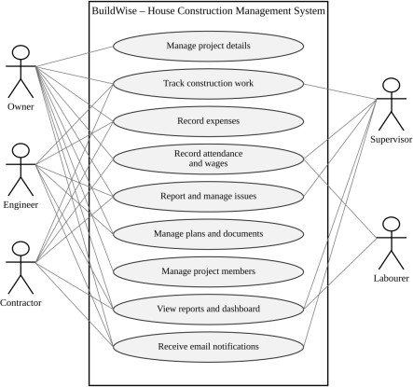
Figure 2.1: Use case diagram of BuildWise Three key use cases are described below.
Table 2.5: Use case description – Record attendance and calculate wage

Use Case ID | UC-01
Use Case Name | Record attendance and calculate wage
Actor(s) | Supervisor, Contractor
Pre-condition | The user is signed in with a role permitted to add attendance records, and the project exists.

Main Flow | - The user opens the Attendance and Salary form.  - The user selects the project and enters the labourer name, date and daily wage.  - The user selects the attendance status: Present, Half Day or Absent.  - The user submits the form.  - The system calculates the wage according to the status and stores it in the record.
Alternate Flow | If a mandatory field is empty, the form displays a validation message and the record is not saved.
Post-condition | The attendance record is saved with the calculated wage and appears in the Attendance and Salary report.
Related FR | FR-07, FR-08

Table 2.6: Use case description – Record an expense and check the project budget

Use Case ID | UC-02
Use Case Name | Record an expense and check the project budget
Actor(s) | Owner, Contractor
Pre-condition | The project exists and has an estimated budget.
Main Flow | - The user opens the Expense Tracker form.  - The user selects the project and enters the expense details and amount.  - The user submits the form.  - The system adds the expense to the total expenses of the project.  - The system compares the total with the estimated budget.  - If the total is greater than the budget, a warning is displayed.
Alternate Flow | If the total does not exceed the estimated budget, the record is saved without a warning.
Post-condition | The expense is stored; the budget warning is displayed when the estimate is exceeded.
Related FR | FR-04, FR-05

Table 2.7: Use case description – Report an issue and notify the project owner

Use Case ID | UC-03
Use Case Name | Report an issue and notify the project owner
Actor(s) | Supervisor, Contractor, Engineer
Pre-condition | The user is signed in and the project exists.
Main Flow | - The user opens the Issue and Delay Manager form.  - The user selects the project and describes the issue or delay.  - The user submits the form.  - The system stores the issue and sends an email notification.  - When the issue is later marked as resolved, the system sends a resolution notification.
Alternate Flow | If the email cannot be delivered, the issue record is still saved. The failure does not undo the save; the issue remains available in the Issue and Delay Manager report.
Post-condition | The issue is recorded and the relevant persons are informed by email.
Related FR | FR-09, FR-10

  - System Architecture
Chapter 3
System Design

BuildWise follows the layered structure of a Zoho Creator application, as shown in the figure below. Users from the five roles access the application through a web browser after signing in. The presentation layer consists of the seven forms, their reports and the BuildWise Home Dashboard. The business logic layer consists of Deluge scripts, form and schedule workflows and the role-based access control that determines what each user may see and do. Records are stored in the built-in data store of Zoho Creator, so no external database is used. Email notifications are produced by the workflows through the email facility of the platform.
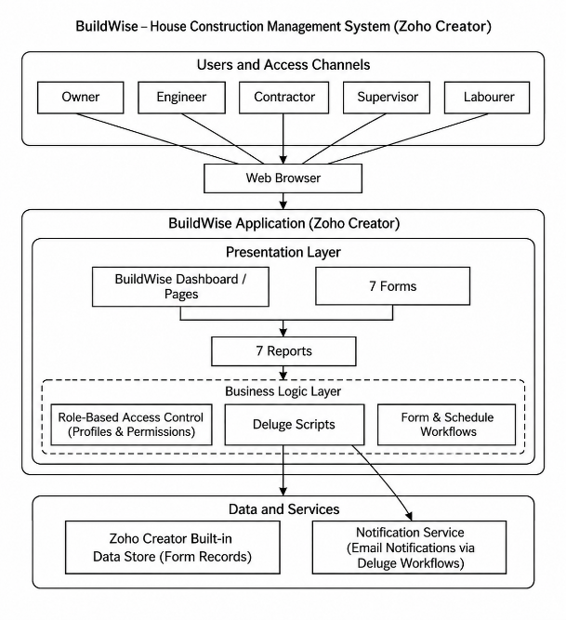
Figure 3.1: System architecture of BuildWise
The architecture does not include connections to other Zoho products or to external application programming interfaces (APIs). This keeps the application self-contained and keeps the report consistent with the implemented features.
  - Data Model
The data model is centred on the Project Details form. Every other form records information that belongs to a project, so each of them is designed to carry a lookup to Project Details, giving a one-to-many relationship between a project and its work items, expenses, attendance records, issues, documents and members. The entity–relationship (ER) diagram shows this structure. The field names are drafted from the described functionality and are to be verified against the Form Builder.

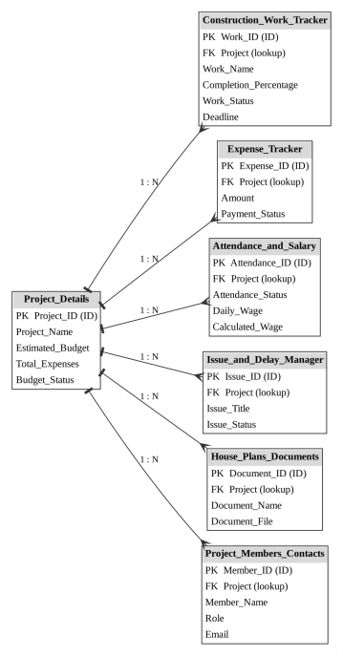
Figure 3.2: Entity–relationship diagram of BuildWise Table 3.1: Entities and relationships
Entity (form) | Key fields | Related to | Relationship | Implemented using
Project Details | Project Name, Estimated Budget, Total Expenses | All other forms | One-to-many | Lookup in the child form (mandatory Project lookup field)
Construction Work Tracker | Work Name, Completion Percentage, Work Status, Deadline | Project Details | Many-to-one | Lookup field
Expense Tracker | Amount, Payment Status | Project Details | Many-to-one | Lookup field
Attendance and Salary | Attendance Status, Daily Wage, Calculated Wage | Project Details | Many-to-one | Lookup field
Issue and Delay Manager | Issue Title, Issue Status | Project Details | Many-to-one | Lookup field
House Plans Documents | Document Name, Document File | Project Details | Many-to-one | Lookup field
Project Members Contacts | Member Name, Role, Email | Project Details | Many-to-one | Lookup field

  - Form Design
The field specification of each form is given below. Because the field list of the application was not supplied while preparing this report, the tables show the fields that are required by the described automation together with the fields normally needed by each module. Field types, mandatory settings and link names follow Zoho Creator conventions and must be checked against the Form Builder before submission. The Remarks column indicates fields that are required by a workflow.

    - Project Details
Table 3.2: Field specification – Project Details form

Field label | Link name | Field type | Mandatory | Validation / default | Remarks
Project Name | Project_Name | Single Line | Yes | – | Identifies the project
Project Location | Project_Location | Single Line | Yes | – | Place where the house is being constructed
Owner Name | Owner_Name | Single Line | Yes | – | Name of the house owner
Owner Email | Owner_Email | Email | Yes | Valid email format | Recipient of notifications (issue, expense and resolution emails)
Start Date | Start_Date | Date | No | – | Date on which construction begins
Estimated Budget | Estimated_Budge t | Currency | Yes | Greater than 0 | Used by budget alert
Total Expenses | Total_Expenses | Currency | No | System calculated | Used by budget alert (updated by the budget alert workflow)
Budget Status | Budget_Status | Single Line  / Drop Down | No | Set by workflow | Shows Within Budget or Budget Exceeded

    - Construction Work Tracker
Table 3.3: Field specification – Construction Work Tracker form

Field label | Link name | Field type | Mandatory | Validation / default | Remarks
Project | Project | Lookup | Yes | Project Details | Links work to a project
Work Name | Work_Name | Single Line | Yes | – | Activity such as foundation or roofing
Start Date | Start_Date | Date | No | – | Planned start date of the work
Deadline | Deadline | Date | Yes | – | Used by reminder schedule
Completion Percentage | Completion_Perc entage | Number | Yes | 0 to 100 | Used by status automation
Work Status | Work_Status | Drop Down | No | Not Started / In Progress / Completed | Set automatically
Remarks | Remarks | Multi Line | No | – | Site notes or comments on the work

    - Expense Tracker
Table 3.4: Field specification – Expense Tracker form

Field label | Link name | Field type | Mandatory | Validation / default | Remarks
Project | Project | Lookup | Yes | Project Details | Used for total expenses
Expense Date | Expense_Date | Date | Yes | Default: today (set as field default) | –
Expense Category | Expense_Categor y | Drop Down | No | Material / Labour / Transport / Equipment / Miscellaneous | Groups expenses by type
Description | Description | Multi Line | No | – | –
Amount | Amount | Currency | Yes | Greater than 0 | Summed against the budget
Payment Status | Payment_Status | Drop Down | Yes | Pending / Partially Paid / Paid | Used for confirmation email

    - Attendance and Salary
Table 3.5: Field specification – Attendance and Salary form

Field label | Link name | Field type | Mandatory | Validation / default | Remarks
Project | Project | Lookup | Yes | Project Details | –
Labourer Name | Labourer_Name | Single Line | Yes | – | Text field; the labourer is typed in, not looked up
Attendance Date | Attendance_Date | Date | Yes | Default: today (set as field default) | –
Attendance Status | Attendance_Statu s | Radio / Drop Down | Yes | Present / Half Day  / Absent | Used by wage calculation
Daily Wage | Daily_Wage | Currency | Yes | Greater than or equal to 0 | Used by wage calculation
Calculated Wage | Calculated_Wage | Currency | No | Read-only; set by script | Output of wage calculation

    - Issue and Delay Manager
Table 3.6: Field specification – Issue and Delay Manager form

Field label | Link name | Field type | Mandatory | Validation / default | Remarks
Project | Project | Lookup | Yes | Project Details | –
Issue Title | Issue_Title | Single Line | Yes | – | Used in email subject
Issue Description | Issue_Description | Multi Line | Yes | – | Used in email message
Issue Type | Issue_Type | Drop Down | No | Issue / Delay (drop-down choices) | Separates a construction issue from a delay
Reported Date | Reported_Date | Date | No | Default: today (set as field default) | –

Field label | Link name | Field type | Mandatory | Validation / default | Remarks
Issue Status | Issue_Status | Drop Down | Yes | Includes Resolved | Triggers resolution email

    - House Plans Documents
Table 3.7: Field specification – House Plans Documents form

Field label | Link name | Field type | Mandatory | Validation / default | Remarks
Project | Project | Lookup | Yes | Project Details | –
Document Name | Document_Name | Single Line | Yes | – | –
Document Type | Document_Type | Drop Down | No | House Plan / Approval / Estimate / Contract  / Other | Classifies the document
Document File | Document_File | File Upload | Yes | – | Stores the plan or document
Remarks | Remarks | Multi Line | No | – | –

    - Project Members Contacts
Table 3.8: Field specification – Project Members Contacts form

Field label | Link name | Field type | Mandatory | Validation / default | Remarks
Project | Project | Lookup | Yes | Project Details | –
Member Name | Member_Name | Single Line | Yes | – | –
Role | Role | Drop Down | Yes | Owner / Engineer / Contractor / Supervisor / Labourer (drop-down choices) | –
Phone | Phone | Phone | No | – | –
Email | Email | Email | No | Valid email format | –

  - Process and Workflow Design
    - Data flow diagrams
The context-level data flow diagram (DFD) shows BuildWise as a single process that exchanges data with project users and email recipients. The level-1 diagram expands the system into four processes: capturing and validating data, applying automation rules, generating reports and the dashboard, and sending email notifications.
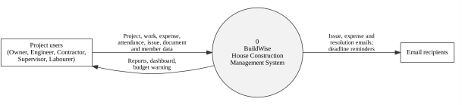
Figure 3.3: Level 0 data flow diagram of BuildWise

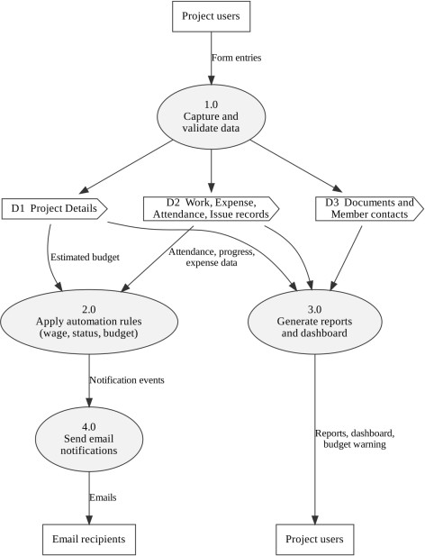
Figure 3.4: Level 1 data flow diagram of BuildWise
    - Automatic wage calculation
When an attendance record is submitted, the system reads the attendance status and the daily wage. A Present status gives the full daily wage, a Half Day status gives half of the daily wage and an Absent status gives zero. The result is stored in the calculated wage field of the same record.
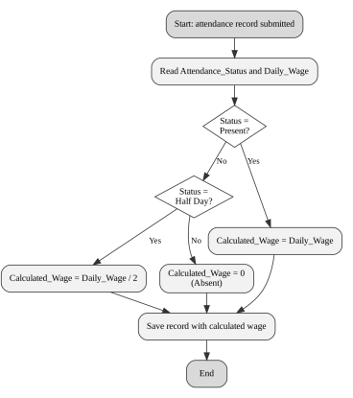
Figure 3.5: Process flow for automatic wage calculation
    - Project budget alert
When an expense is recorded or updated, the total of all expenses of the project is compared with the estimated budget stored in Project Details. If the total is greater than the estimated budget, a warning is displayed to the user.

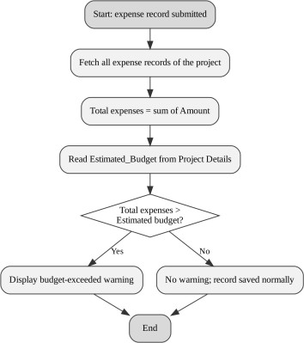
Figure 3.6: Process flow for the project budget alert
    - Work status automation
The work status is derived from the completion percentage: zero means Not Started, one hundred means Completed, and any value in between means In Progress. The user does not need to set the status manually.
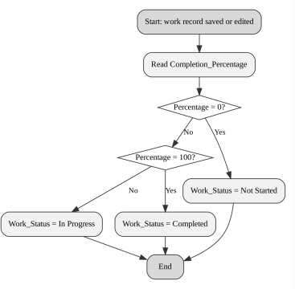
Figure 3.7: Process flow for work status automation
    - Email notification workflows
Three form events produce email notifications: a new record in the Issue and Delay Manager form (issue notification), an update of a record in the Expense Tracker form (expense payment confirmation) and the change of an issue status to Resolved (issue resolution notification).
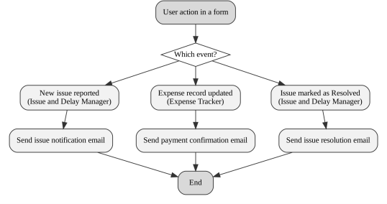
Figure 3.8: Process flow for email notification workflows
    - Deadline reminder and overdue work alert
A scheduled workflow runs at regular intervals, finds construction work that is not completed and whose deadline is approaching, and sends a reminder email. The overdue work alert extends this idea to work whose deadline has already passed. It is shown with a dashed outline in the figure because it is a planned automation and is not claimed as implemented.

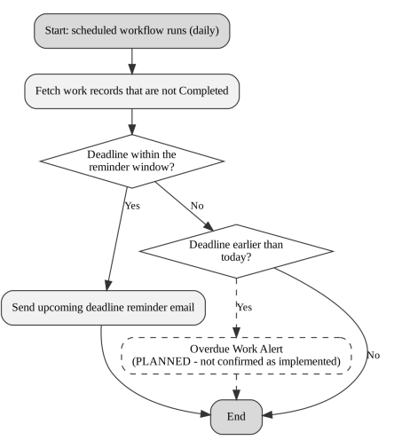
Figure 3.9: Process flow for deadline reminder and planned overdue alert

  - User Interface and Navigation Design
The application opens on the BuildWise Home Dashboard, which provides a central overview of project information. The navigation menu lists one entry for each of the seven modules; each module offers its form for data entry and its report for viewing the stored records. This arrangement allows a user to move from the dashboard to any module in one step.
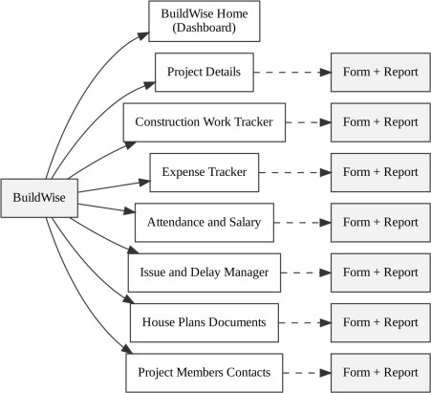
Figure 3.10: Navigation structure of BuildWise
The dashboard is intended to present summary information drawn from the forms, such as project and budget information, work progress, expenses, attendance, open issues and quick links to the forms. The exact panels, charts and quick links in the implemented dashboard are described in Section 4.4 (project overview, work progress, expense summary, open issues and quick links).
  - Access Control Design
Access is organised by the five roles using the letters A for Add, E for Edit, V for View, D for Delete and – for no access. The matrix below records the design intent for each role. The permissions actually configured in the application are to be verified against the profiles in Zoho Creator and corrected here if they differ.

Table 3.9: Role–permission matrix (design intent)

Component | Owner | Engineer | Contractor | Supervisor | Labourer
Form: Project Details | A E V D | V | V | V | –
Form: Construction Work Tracker | A E V D | A E V | E V | E V | V
Form: Expense Tracker | A E V D | V | A E V (own) | – | –
Form: Attendance and Salary | A E V D | V | A E V | A E V | V (own)
Form: Issue and Delay Manager | A E V D | A E V | A E V | A E V | A V (own)
Form: House Plans Documents | A E V D | A E V | V | V | –
Form: Project Members Contacts | A E V D | V | V | V | –
Reports (corresponding to the forms) | V | V | V | V | V  (permitted)
Page: BuildWise Home Dashboard | V | V | V | V | –

Chapter 4
Implementation
This chapter describes how BuildWise was implemented on Zoho Creator. Each component is explained in terms of what it does, how it is configured and where a screenshot is to be placed. Screenshots and configuration details that could not be verified while preparing this report are marked with placeholders. The Deluge scripts shown in this chapter and in Appendix B are drafted to reflect the described logic of each workflow; they must be replaced or corrected with the exact code from the application before submission.
  - Application Setup
The application named BuildWise was created in a Zoho Creator workspace under a Professional-edition trial account as an application built from scratch. The seven forms were created first, followed by the reports, the BuildWise Home Dashboard page, the workflows and the user roles. The navigation menu of the application is organised so that the BuildWise Home Dashboard appears first, followed by one section for each of the seven modules. The application link name and the published address are recorded in the Project at a Glance table.
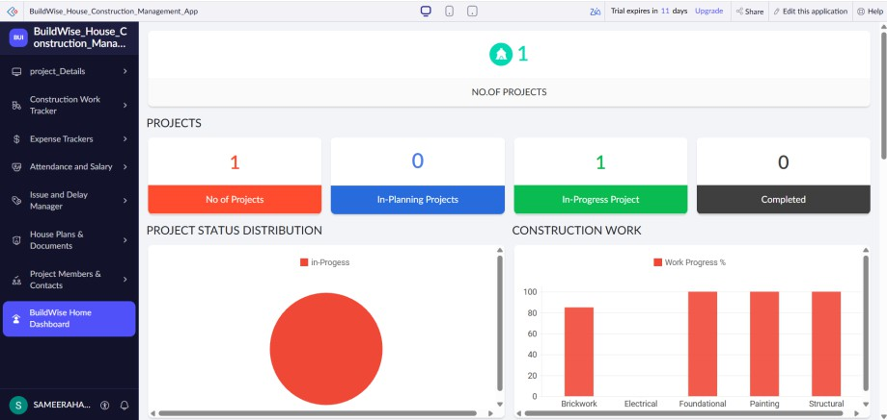
Figure 4.1: BuildWise home page and navigation sections

  - Forms and Data Capture
The application contains seven forms, which capture the data of a house construction project. The purpose and main functions of each form are given in the table below, and the fields are specified in Section 3.3. Mandatory fields, drop-down choices and lookups ensure that the data entered by the users is complete and consistent.
Table 4.1: Forms and their purpose

No. | Form | Purpose and functionality
1 | Project Details | Stores the basic information of a project, including the estimated budget against which expenses are compared.
2 | Construction Work Tracker | Records each construction activity with its completion percentage and deadline; the work status is set automatically.
3 | Expense Tracker | Records the expenses of the project; updating a record triggers a payment confirmation email, and the total feeds the budget alert.
4 | Attendance and Salary | Records the daily attendance of labourers and the wage calculated from the attendance status.
5 | Issue and Delay Manager | Records problems and delays found on site; a new issue and its resolution trigger email notifications.

No. | Form | Purpose and functionality
6 | House Plans Documents | Stores house plans and other project documents so that they are available with the project.
7 | Project Members Contacts | Stores the contact details of the people involved in the project.

    - Project Details form
The Project Details form is the parent record of the application. It holds the project name, location, owner details and the estimated budget. The estimated budget is a mandatory currency field because the project budget alert depends on it.
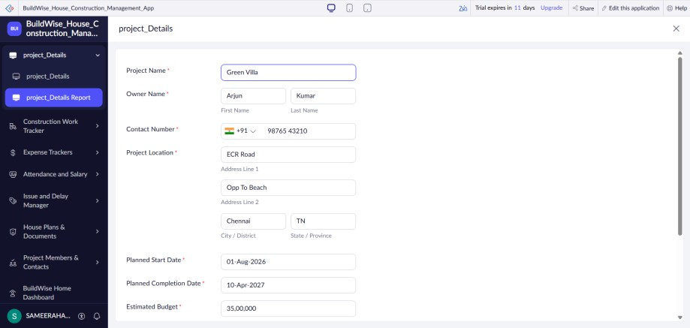
Figure 4.2: Project Details form in live mode
    - Construction Work Tracker form
The Construction Work Tracker form records each construction activity with its deadline and completion percentage. The work status field is not entered by the user; it is set by the work status automation described in Section 4.6.
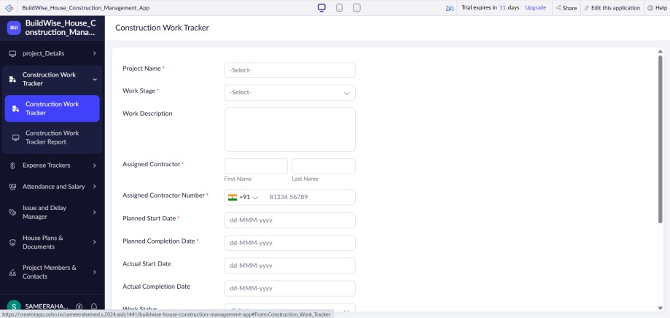
Figure 4.3: Construction Work Tracker form in live mode
    - Expense Tracker form
The Expense Tracker form records the amount and details of each expense against a project. Submitting or updating an expense record runs the budget alert logic, and updating a record sends the payment confirmation email.

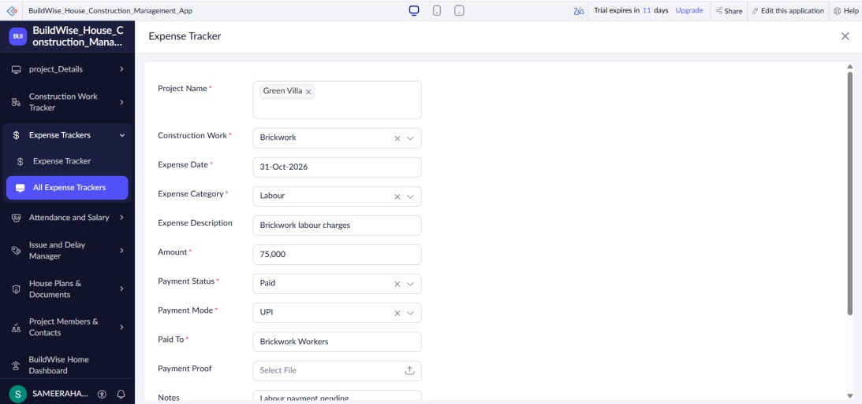
Figure 4.4: Expense Tracker form in live mode
    - Attendance and Salary form
The Attendance and Salary form records whether a labourer was Present, on a Half Day or Absent on a given date, together with the daily wage. The calculated wage field is filled by the wage calculation script and is not entered by the user.
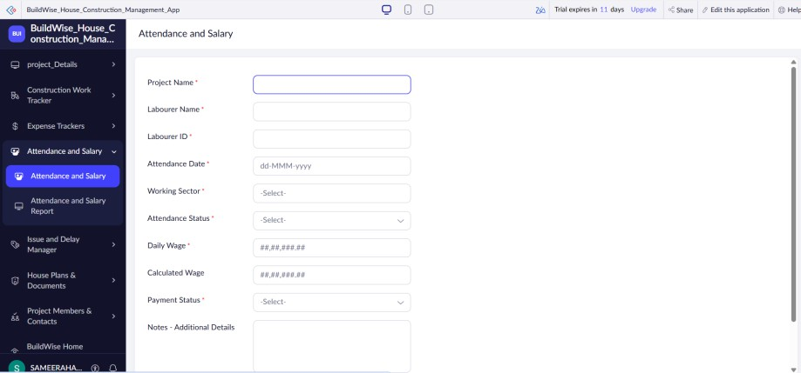
Figure 4.5: Attendance and Salary form in live mode
    - Issue and Delay Manager form
The Issue and Delay Manager form records issues and delays reported from the site. Adding a record sends the issue email notification, and changing the issue status to Resolved sends the issue resolution notification.
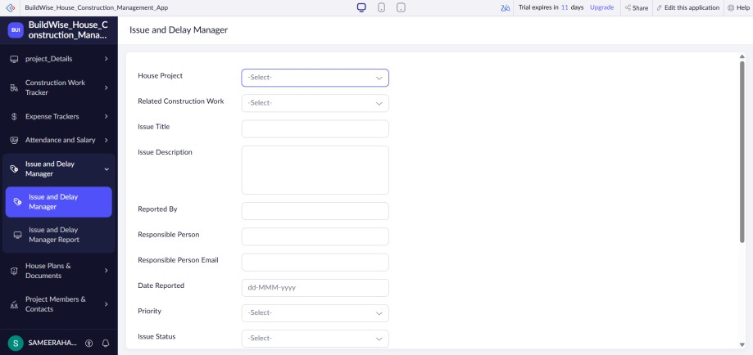
Figure 4.6: Issue and Delay Manager form in live mode

    - House Plans Documents form
The House Plans Documents form stores plan drawings and other documents as uploaded files linked to a project, so that the engineer, contractor and owner refer to the same version.
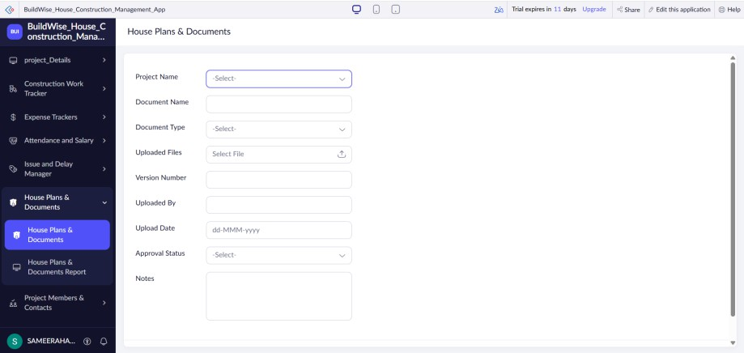
Figure 4.7: House Plans Documents form in live mode
    - Project Members Contacts form
The Project Members Contacts form stores the name, role and contact details of each person involved in the project so that the owner and the site team can contact one another.
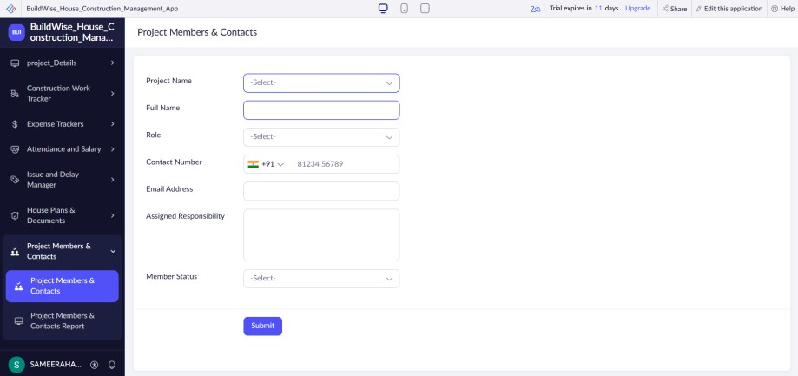
Figure 4.8: Project Members Contacts form in live mode

  - Reports
A report is provided for each of the seven forms so that the stored records can be viewed, searched and sorted. The BuildWise Home Dashboard complements these reports with a summary view. The report type, filters, grouping and custom actions of each report are to be confirmed from the application; the table below records the report names and their source forms.
Table 4.2: Reports implemented

Report name | Type | Source form | Filter / grouping / sorting
Project Details Report | List | Project Details | Sorted by Project Name; no filter
Construction Work Tracker Report | List | Construction Work Tracker | Grouped by Work Status; sorted by Deadline
All Expense Trackers | List | Expense Tracker | Grouped by Payment Status; sorted by Expense Date (latest first)

Report name | Type | Source form | Filter / grouping / sorting
Attendance and Salary Report | List | Attendance and Salary | Sorted by Attendance Date (latest first); quick filter on Attendance Status
Issue and Delay Manager Report | List | Issue and Delay Manager | Grouped by Issue Status; sorted by Reported Date
House Plans Documents Report | List | House Plans Documents | Grouped by Document Type
Project Members Contacts Report | List | Project Members Contacts | Grouped by Role
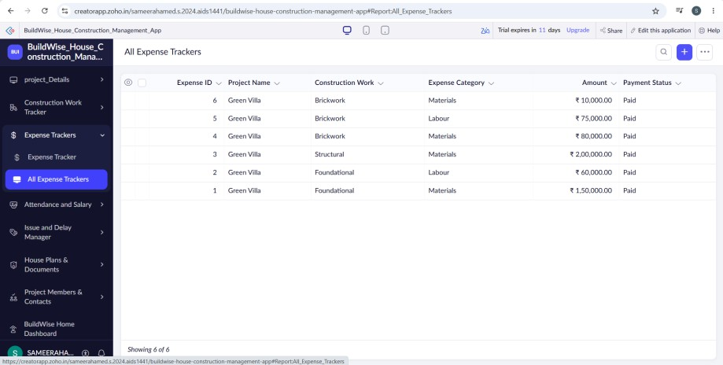
Figure 4.9: Representative report of BuildWise

  - Pages and Dashboards
The BuildWise Home Dashboard is a Zoho Creator page that serves as the home page of the application. Its purpose is to give the Owner, Engineer, Contractor and Supervisor a centralised overview of project information without opening each report separately. The components placed on the dashboard (summary panels, charts, embedded reports and quick links) are a project overview panel (project name, owner, budget and status), work-progress and expense summaries, a list of open issues and quick links to the seven forms and reports. No dashboard figure is quoted in this report that has not been verified in the application.
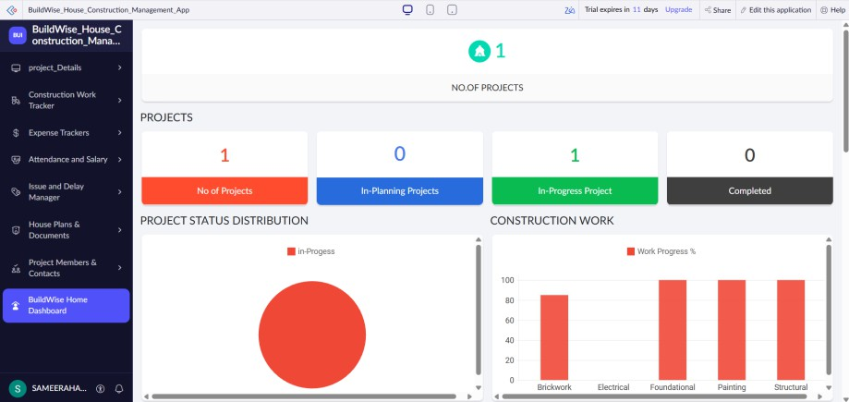
Figure 4.10: BuildWise Home Dashboard

  - Deluge Scripting
Deluge is the scripting language of Zoho Creator [3]. In BuildWise it is used for the rules that cannot be defined by form configuration alone: calculating wages, comparing expenses with the budget, setting the work status and composing email notifications. The scripts are small and each is attached to one form event or to one schedule. The table lists the scripts; the full listing is in Appendix B.
Table 4.3: Deluge scripts implemented

Script ID | Location / trigger (to be confirmed) | Purpose | Deluge concepts used
DS-01 | Attendance and Salary → form workflow | Calculate wage from attendance status | if–else, arithmetic, ifnull
DS-02 | Expense Tracker → form workflow | Compare total expenses with estimated budget and show warning | fetch with criteria, sum, if–else, alert, update
DS-03 | Construction Work Tracker  → form workflow | Set work status from completion percentage | if–else, field assignment
DS-04 | Issue and Delay Manager → on add | Email notification for a new issue | fetch, sendmail, string concatenation
DS-05 | Expense Tracker → on edit | Email for payment confirmation | fetch, sendmail
DS-06 | Schedule workflow | Reminder for upcoming work deadlines | date functions, criteria fetch, for each, sendmail
DS-07 | Schedule workflow (planned) | Overdue work alert – not confirmed as implemented | date comparison, criteria fetch, sendmail
DS-08 | Issue and Delay Manager → on edit | Email when an issue is resolved | if condition, fetch, sendmail

Code 4.1: Wage calculation logic (DS-01, draft)
// DS-01 | Attendance and Salary | wage calculation dailyWage = ifnull(input.Daily_Wage, 0); if(input.Attendance_Status == "Present")
{
input.Calculated_Wage = dailyWage;
}
else if(input.Attendance_Status == "Half Day")
{
input.Calculated_Wage = dailyWage / 2;
}
else
{
input.Calculated_Wage = 0;
}

The script reads the daily wage, replaces an empty value by zero and assigns the calculated wage according to the attendance status. The attendance status values must match the choices configured in the form.
Code 4.2: Work status logic (DS-03, draft)
// DS-03 | Construction Work Tracker | status automation pct = ifnull(input.Completion_Percentage, 0);
if(pct <= 0)
{
input.Work_Status = "Not Started";
}

else if(pct >= 100)
{
input.Work_Status = "Completed";
}
else
{
input.Work_Status = "In Progress";
}

  - Workflows and Automation
BuildWise contains eight automations. Seven are described as implemented, and one, the overdue work alert, is planned. The trigger events shown in the table are the intended events and must be confirmed against the workflow configuration of the application.
Table 4.4: Workflows and automation

No. | Workflow | Type | Trigger (to be confirmed) | Action | Status
1 | Automatic Wage Calculation | Form workflow | Attendance record added / edited | Calculate and store wage | Implemented
2 | Project Budget Alert | Form workflow | Expense record added  / edited | Compare total with budget; display warning | Implemented
3 | Work Status Automation | Form workflow | Work record added / edited | Set status from completion percentage | Implemented
4 | Issue Email Notification | Form workflow | Issue record added | Send email | Implemented
5 | Expense Payment Confirmation | Form workflow | Expense record updated | Send email | Implemented
6 | Upcoming Work Deadline Reminder | Schedule workflow | Scheduled run | Send reminder email | Implemented
7 | Overdue Work Alert | Schedule workflow | Scheduled run | Identify overdue work and alert | Planned
8 | Issue Resolution Notification | Form workflow | Issue status set to Resolved | Send email | Implemented

    - Automatic wage calculation
      - The user submits an attendance record with the attendance status and daily wage.
      - The workflow reads the attendance status.
      - If the status is Present, the calculated wage is set equal to the daily wage.
      - If the status is Half Day, the calculated wage is set to half of the daily wage.
      - If the status is Absent, the calculated wage is set to zero.
      - The record is saved with the calculated wage and appears in the Attendance and Salary report.
    - Project budget alert
      - The user adds or edits an expense record for a project.
      - The workflow collects all expense records of that project and calculates their total.
      - The workflow reads the estimated budget from the Project Details record.
      - The total expenses are compared with the estimated budget.

      - If the total exceeds the budget, a warning message is displayed to the user; otherwise no warning is shown.
Code 4.3: Budget alert logic (DS-02, draft)
// DS-02 | Expense Tracker | budget alert
total = ifnull(Expense_Tracker[Project == input.Project]
.sum(Amount), 0);
proj = Project_Details[ID == input.Project]; proj.Total_Expenses = total;
if(total > proj.Estimated_Budget)
{
proj.Budget_Status = "Budget Exceeded";
alert "Warning: total expenses exceed the estimated budget.";
}
else
{
proj.Budget_Status = "Within Budget";
}

    - Work status automation
      - The user adds or edits a work record and enters the completion percentage.
      - If the percentage is zero, the status is set to Not Started.
      - If the percentage is one hundred, the status is set to Completed.
      - For any other value, the status is set to In Progress.
      - The record is saved with the updated status.
    - Issue email notification
      - A user submits a new record in the Issue and Delay Manager form.
      - The workflow fetches the project record to obtain the project name and the recipient email address.
      - An email is composed with the issue title, description and project name.
      - The email is sent to the recipient configured in the workflow (the Owner Email stored in Project Details).
Code 4.4: Issue notification logic (DS-04, draft)
// DS-04 | Issue and Delay Manager | on add proj = Project_Details[ID == input.Project]; sendmail
[
from :zoho.adminuserid to :proj.Owner_Email
subject :"New issue reported: " + input.Issue_Title message :"Project: " + proj.Project_Name + "<br>"
+ input.Issue_Description
]

    - Expense payment confirmation
      - A user edits and saves an existing expense record.
      - The workflow collects the project name, amount and payment status of the record.
      - An email is composed confirming the payment details.
      - The email is sent to the configured recipient (the Owner Email stored in Project Details).

    - Upcoming work deadline reminder
      - The schedule workflow runs at the configured interval (once every day).
      - It finds the work records that are not Completed and whose deadline falls within the reminder period (the next three days).
      - For each such record, the project and work details are collected.
      - A reminder email is sent to the configured recipient. Code 4.5: Deadline reminder logic (DS-06, draft)
// DS-06 | Schedule workflow | deadline reminder windowDays = 3; // illustrative value
limitDate = zoho.currentdate.addDay(windowDays);
dueList = Construction_Work_Tracker[Deadline >= zoho.currentdate && Deadline <= limitDate
&& Work_Status != "Completed"]; for each w in dueList
{
proj = Project_Details[ID == w.Project]; sendmail
[
from :zoho.adminuserid to :proj.Owner_Email
subject :"Deadline approaching: " + w.Work_Name message :"Deadline: " + w.Deadline
]
}

    - Overdue work alert (planned)
The overdue work alert is intended to identify work records that are not Completed and whose deadline is earlier than the current date, and to alert the responsible persons. Its implementation is not confirmed, so it is presented in this report as a planned automation. A proposed script is given in Appendix B for reference only, and the corresponding test case is not counted among the executed tests.
    - Issue resolution notification
      - A user edits an issue record and sets the issue status to Resolved.
      - The workflow checks that the issue status is Resolved.
      - The project name and issue details are collected.
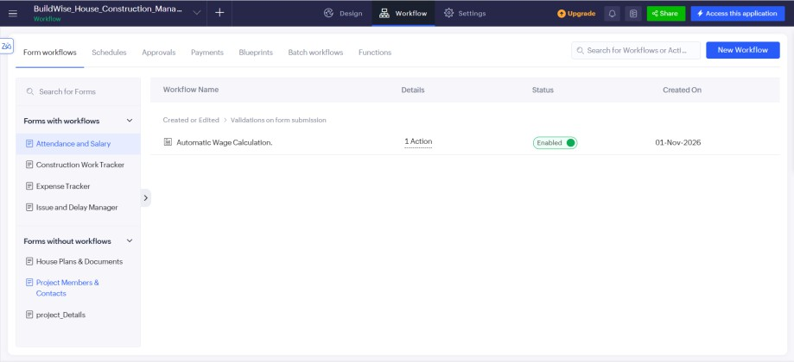
      - An email is sent informing the recipient that the issue has been resolved (the project owner).
Figure 4.11: Workflow configuration in Zoho Creator

  - Integrations
BuildWise does not integrate with other Zoho products or with external services, and it does not use connections, invokeurl calls, webhooks or the Creator REST API. The only outbound communication is the email sent from Deluge workflows through the email facility of Zoho Creator.
Table 4.5: Integrations and outbound communication

Item | Service | Method | Status
Email notifications | Zoho Creator email facility | Deluge sendmail | Implemented
Other Zoho products | – | – | Not used
External REST APIs | – | – | Not used

  - User Management and Role-Based Access
Access to BuildWise is organised for five roles: Owner, Engineer, Contractor, Supervisor and Labourer. The permission matrix of Section 3.6 defines what each role may add, edit, view or delete. In Zoho Creator this is realised through users, roles and permission profiles. The users created, the profiles defined and any record-level criteria (for example, a Labourer seeing only own attendance) are as follows: one demonstration user for each role, one permission profile for each role, and a criterion that limits the Labourer to own attendance records.
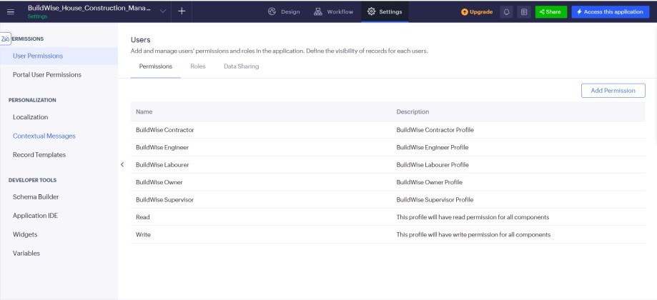
Figure 4.12: Roles and permission profiles configuration

  - AI and Analytics Features
No Zia or other AI feature is used in BuildWise. The analytical view of the project is provided by the BuildWise Home Dashboard and the reports of the application; the use of charts on the dashboard is limited to a small number of summary charts. No integration with Zoho Analytics is claimed.
  - Pro-Code Extension
No pro-code extension such as Zoho Catalyst functions, JavaScript widgets or custom REST services is used. The requirements of the project could be met with forms, reports, a page, workflows and Deluge scripts, so pro-code was not necessary. If the project is extended in future, a pro-code component could be used for heavy processing, advanced charts or integration with accounting or payment services.

  - Mobile and Portal Access
Zoho Creator applications can be opened in a web browser and, where enabled, in the Zoho Creator mobile application. Access to BuildWise from a mobile device and the use of a customer portal were not described for this project, and no claim of mobile or portal testing is made.

  - Testing Strategy
Chapter 5
Testing and Debugging

The testing strategy follows the structure of the application. Unit testing checks each form, including mandatory fields and the individual Deluge scripts. Integration testing checks the workflows that combine several forms, such as the budget alert that uses expense and project records, and the email notifications that use form events. Role-based testing signs in as each of the five roles and checks the visible forms, reports and the dashboard. User acceptance testing records the feedback of users who tried the application in their assigned role.
The test cases below were designed from the functional requirements of Chapter 2. Test data are illustrative values chosen to exercise the rules; they are not records of a real construction project. The Actual Result and Status columns are marked as placeholders because the outcome of each test has to be recorded after execution in the application, and no result is claimed here.
  - Test Cases
Table 5.1: Test cases

TC ID | FR | Test description | Input / steps | Expected result | Actual result | Status
TC-01 | FR-01 | Create a project with all mandatory fields | Project name, location, owner email, estimated budget 1,500,000 | Record saved; success message shown | Record saved; success message displayed | Pass
TC-02 | FR-01 | Submit project without the estimated budget | Leave Estimated Budget empty | Validation message; record not saved | Validation message shown; record not saved | Pass
TC-03 | FR-03 | Work with zero completion | Completion percentage  = 0 | Work Status = Not Started | Work Status set to Not Started | Pass
TC-04 | FR-03 | Work partly completed | Completion percentage  = 45 | Work Status = In Progress | Work Status set to In Progress | Pass
TC-05 | FR-03 | Work fully completed | Completion percentage  = 100 | Work Status = Completed | Work Status set to Completed | Pass
TC-06 | FR-02 | Boundary: completion above 100 | Completion percentage  = 120 | Value rejected or flagged (a 0 to 100 range validation on the field) | Value 120 rejected by the 0 to 100 range validation | Pass
TC-07 | FR-08 | Wage for Present | Status = Present; daily wage = 800 | Calculated wage = 800 | Calculated wage  = 800 | Pass
TC-08 | FR-08 | Wage for Half Day | Status = Half Day; daily wage = 800 | Calculated wage = 400 | Calculated wage  = 400 | Pass
TC-09 | FR-08 | Wage for Absent | Status = Absent; daily wage = 800 | Calculated wage = 0 | Calculated wage  = 0 | Pass
TC-10 | FR-08 | Edit status of an existing record | Change Present to Absent and save | Calculated wage becomes 0 (the workflow runs on both create and edit) | Calculated wage updated to 0 | Pass
TC-11 | FR-05 | Expenses within budget | Estimated budget 1,000,000; expenses  600,000 + 300,000 | Total 900,000; no warning | Total 900,000; no warning displayed | Pass
TC-12 | FR-05 | Expenses exceed budget | Add a further expense of 150,000 to the project above | Total 1,050,000;  budget-exceeded warning displayed | Total 1,050,000;  budget-exceeded warning displayed | Pass
TC-13 | FR-04 | Expense without amount | Leave Amount empty | Validation message; record not saved | Validation message shown; record not saved | Pass

TC ID | FR | Test description | Input / steps | Expected result | Actual result | Status
TC-14 | FR-06 | Payment confirmation email | Edit and save an existing expense record | Confirmation email received by the recipient | Confirmation email received | Pass
TC-15 | FR-09 | New issue notification | Submit a new issue | Issue notification email received | Issue notification email received | Pass
TC-16 | FR-10 | Issue resolution notification | Set Issue Status to Resolved and save | Resolution email received | Resolution email received | Pass
TC-17 | FR-11 | Deadline reminder | Work with deadline within the reminder period and not Completed; run the schedule | Reminder email received; no email for Completed work | Reminder email received; none for Completed work | Pass
TC-18 | FR-12 | Overdue work alert (planned) | Work with deadline earlier than today | Not applicable – automation planned, not tested | Not tested – automation is planned | N/A
TC-19 | FR-13 | Upload house plan | Add a document with file attached | Record saved; file available in the report | Record saved; file available in the report | Pass
TC-20 | FR-14 | Add project member | Enter name, role, phone, email | Record saved; shown in the Project Members Contacts report | Record saved; shown in the Project Members Contacts report | Pass
TC-21 | FR-15 | Open each report | Open the seven reports | Records of the corresponding form are listed | Records listed in each report | Pass
TC-22 | FR-16 | Open the dashboard | Sign in as Owner and open BuildWise Home Dashboard | Dashboard loads with project overview | Dashboard loaded with project overview | Pass
TC-23 | FR-17 | Labourer access restriction | Sign in as Labourer; try to open Expense Tracker | Access denied or form not visible | Expense Tracker not visible to the Labourer | Pass
TC-24 | FR-17 | Owner full access | Sign in as Owner; open all forms | All forms available for add, edit, view and delete | All forms available with add, edit, view and delete | Pass

  - Debugging Deluge Scripts
Deluge scripts can be debugged in several ways. The info statement writes a value to the execution log, so that intermediate values such as the calculated total or the attendance status can be checked. The script editor reports syntax errors before a script is saved. When a form submission fails, the error message displayed to the user and the workflow execution log indicate the script line that caused the problem. Typical causes of errors in scripts of this kind are mismatches between field link names and the names used in the script, mismatches between drop-down values and the text compared in conditions, and empty values in arithmetic.
During development, the calculated wage did not change when the Attendance Status of an existing record was edited from Present to Absent. The Deluge script itself was correct, but the workflow had been set to run only when a record was created, so edits never fired it. Printing the status and wage to the Deluge execution log with info statements showed that the script was not being executed on edit. Changing the workflow trigger to Create or Edit fixed the problem, and test case TC-10 now passes.

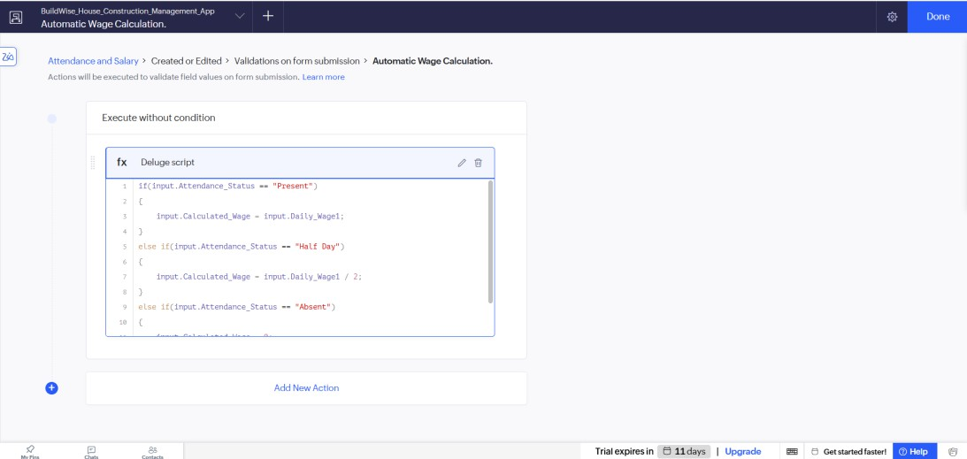
Figure 5.1: Deluge debug output or log

  - Defect Log
No defect information was supplied for this report. The log below must be completed with the defects actually found during testing.
Table 5.2: Defect log

Bug ID | Description | Root cause | Fix applied | Status
BUG-01 | Calculated wage was not updated when the attendance status of an existing record was edited | The wage workflow was configured to run only when a record is created | Workflow trigger changed to Create or Edit so the wage is recalculated on every save | Closed
BUG-02 | Budget warning did not work for a project that had no expense records yet | The fetched total was empty (null), so the comparison with the budget failed | Added a null check so that the total is treated as 0 when no expense exists | Closed

  - User Acceptance Testing
User acceptance testing is recorded by asking at least two users to use the application in their assigned roles. No feedback was available for this report, so the table is left for completion.
Table 5.3: User acceptance feedback

User | Role tested | Feedback | Action taken
User 1 | Owner | The dashboard and email alerts make it easy to follow budget and issues without phone calls. | No change required; the dashboard is kept as the home page.
User 2 | Supervisor | Attendance entry is quick and the wage is shown automatically; field labels are clear. | Default date set to today to reduce typing.

Chapter 6
Deployment, Security and Governance
  - Environments and Deployment Strategy
Zoho Creator provides Development, Stage and Production environments for applications on plans that support them. Which environments were used for BuildWise, and whether the application was published to production, is as follows: the application was built and tested in the Development environment and then published to Production; the Stage environment was not used. The recommended strategy is to build and test in the Development environment, verify the workflows and roles in Stage with sample users, and then publish to Production with release notes so that the previous version can be restored if a problem is found.
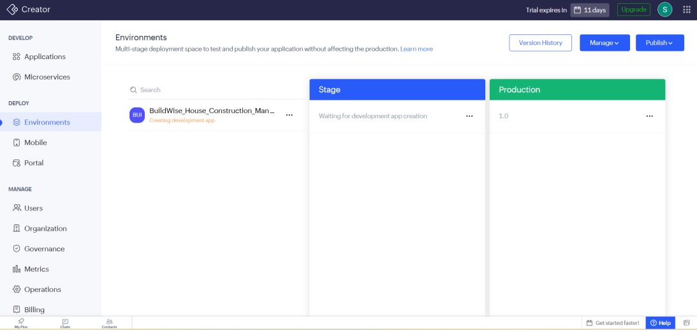
Figure 6.1: Environments and publishing Table 6.1: Deployment checklist

  - Performance Optimisation
S.No. | Checklist item | Done
1 | All test cases executed in Development / Stage | Yes
2 | Sample and test data removed or isolated | Yes
3 | Roles, permissions and users configured in Production | Yes
4 | Schedule workflow enabled and email recipients verified | Yes
5 | Application published and URL verified | Yes
6 | Version and release notes recorded | Yes

No performance measurement was taken for BuildWise, and no improvement figure is claimed. The design choices below are intended to keep the application efficient as the number of records grows. The results columns are to be completed only if measurements are made.

Table 6.2: Performance considerations

Technique applied or recommended | Component | Measured result
Use a single criteria-based fetch to total expenses instead of looping over records | Budget alert (DS-02) | Result shown immediately on save (observed, not timed)
Fetch only work records that are not Completed and are near their deadline | Deadline reminder (DS-06) | Schedule run completed within seconds (observed, not timed)
Limit report columns and apply default filters for large reports | Reports | Reports open quickly with the sample data (observed, not timed)

  - Security Features
Security in BuildWise relies on the facilities of Zoho Creator: users must sign in, and permission profiles control which forms, reports and pages each role can open and what operations it may perform. The table lists the controls relevant to the application and the threat each mitigates; the column Status is to be completed after verifying the configuration.
Table 6.3: Security controls

Security control | Threat mitigated | Where applied | Status
Sign-in required for application access | Access by unauthorised persons | Application | Implemented
Role-based permission profiles | Users changing or viewing data outside their role | Forms, reports, page | Implemented
Record-level criteria for own records | Labourer viewing other persons’ wage data | Attendance and Salary | Implemented
No hard-coded credentials or external keys | Credential leakage | Deluge scripts | No external connections used

  - Governance and Administration
Governance covers how the application is administered after it is delivered. The administrator controls user and licence management, assigns roles and profiles, and can review changes through the audit and history facilities of Zoho Creator. Form, report and field names follow one convention throughout BuildWise, with the form names used in the report text and underscores in link names. Data can be exported from reports as a backup. The person responsible for maintaining the application, the backup frequency and the review of the audit trail are as follows: the student developer acts as administrator and maintainer, reports are exported weekly as a backup, and the audit trail is reviewed before each new release.

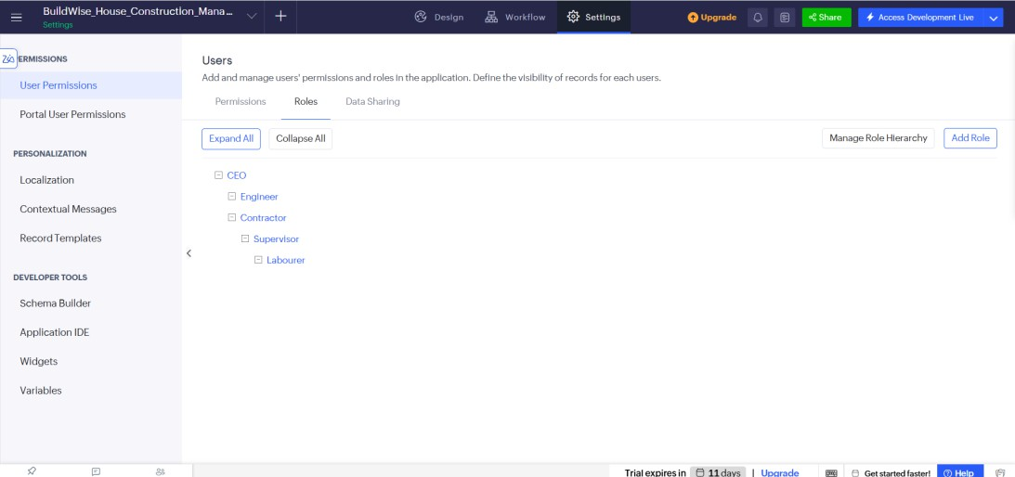
Figure 6.2: Audit trail or administration settings

  - Application Output
Chapter 7
Results and Discussion

This section follows one scenario through the roles of BuildWise. The scenario uses illustrative data and shows how information entered by one role becomes available to the others. The screenshots are to be taken from the application while the scenario is executed.
Step 1: The Owner creates a project in the Project Details form with an estimated budget and records the project members in the Project Members Contacts form. The Engineer uploads the house plans in the House Plans Documents form.
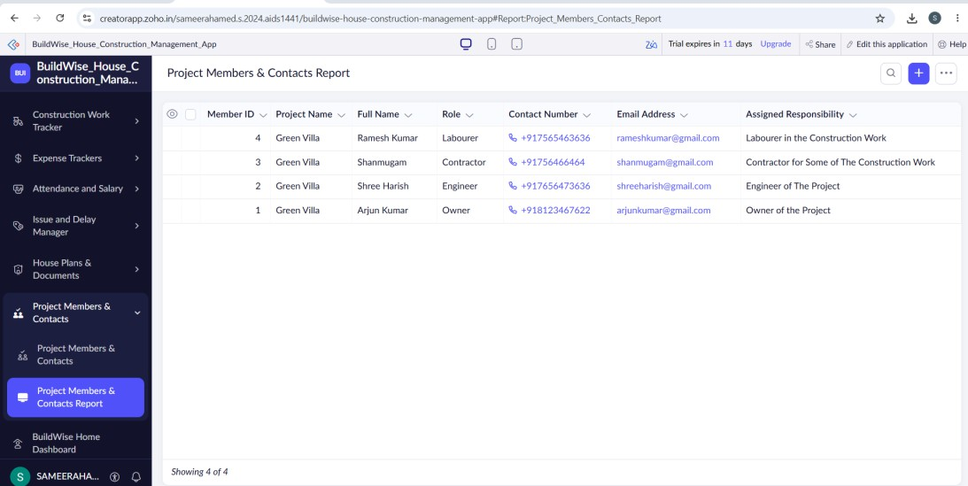
Figure 7.1: Scenario step 1 – project, members and plans
Step 2: The Contractor adds construction work with deadlines. As progress is reported, the completion percentage is updated and the work status changes automatically. The Supervisor records daily attendance, and the wage is calculated from the attendance status.
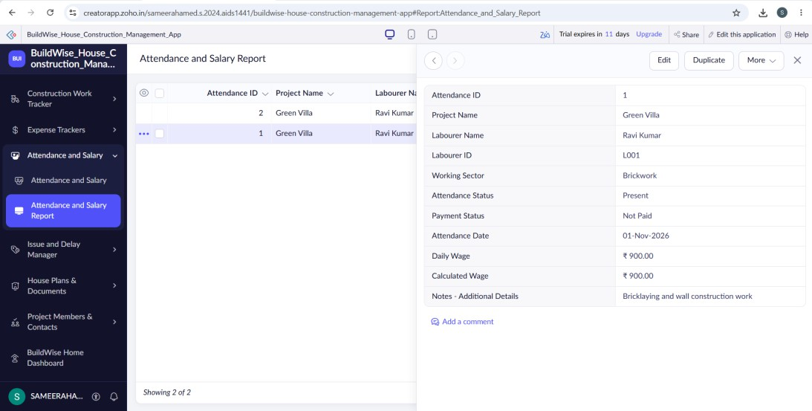
Figure 7.2: Scenario step 2 – work progress and wage calculation
Step 3: Expenses are recorded in the Expense Tracker form. When the total expenses of the project become greater than the estimated budget, a warning is displayed. An issue reported by the Supervisor produces an email notification, and its resolution produces a second email.

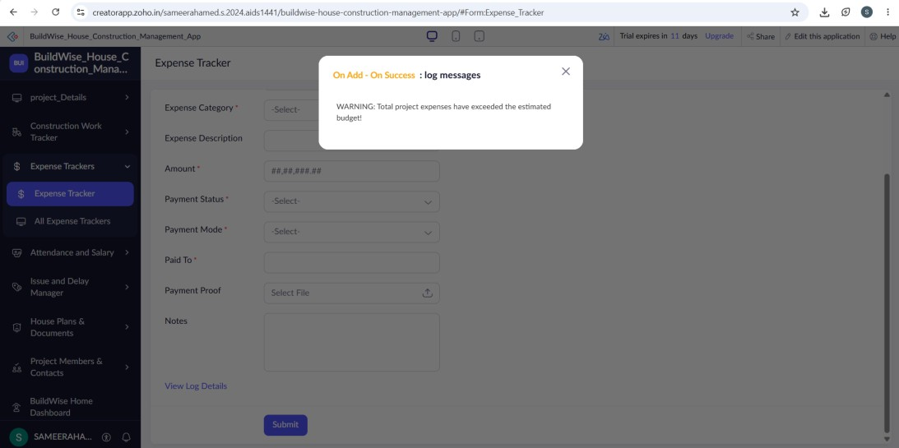
Figure 7.3: Scenario step 3 – budget warning and notifications
Step 4: The Owner opens the BuildWise Home Dashboard and the reports to review the state of the project.
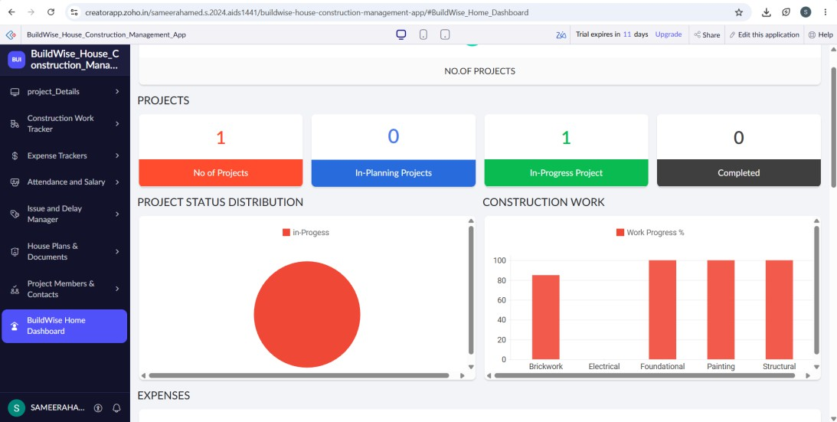
Figure 7.4: Scenario step 4 – dashboard and reports

  - Achievement of Objectives
Table 7.1: Mapping of objectives to outcomes

Objective (Section 1.3) | Implemented through | Outcome / evidence
O1. Seven connected forms | Section 4.2 | Seven forms created; screenshots to be attached
O2. Wage calculation and work status automation | Sections 4.5, 4.6 | Scripts DS-01 and DS-03; test cases TC-03 to TC-10 – all passed
O3. Budget monitoring and warning | Section 4.6.2 | Script DS-02; test cases TC-11 and TC-12 – both passed
O4. Email notifications and deadline reminder | Section 4.6 | Scripts DS-04, DS-05, DS-06, DS-08; test cases TC-14 to TC-17 – all passed. Overdue alert is planned.
O5. Reports and dashboard | Sections 4.3, 4.4 | Reports for the seven forms and the BuildWise Home Dashboard; screenshots to be attached

Objective (Section 1.3) | Implemented through | Outcome / evidence
O6. Access for five roles | Sections 3.6, 4.8 | Role-permission matrix designed; configuration to be confirmed; test cases TC-23, TC-24

  - Comparison with the Existing System
The comparison below is qualitative. It contrasts BuildWise with a typical manual approach in which notebooks, messages and spreadsheets are used. No time saving or numerical improvement is claimed because none was measured.
Table 7.2: Manual approach versus BuildWise

Parameter | Typical manual approach | BuildWise | Improvement
Data storage | Scattered across notebooks, messages and files | Seven connected forms in one application | Centralised records
Wage calculation | Calculated by hand from attendance | Calculated automatically from attendance status | Fewer manual steps
Budget monitoring | Totals compared occasionally | Total compared with estimate; warning when exceeded | Earlier visibility of overrun
Work status | Updated by hand | Set from completion percentage | Status consistent with progress
Communication of issues | Phone call or message | Email on new and resolved issues | Responsible persons informed
Deadline follow-up | Remembered or noted manually | Scheduled reminder | Prompt reminder of due work
Access control | None | Five roles with permissions (configured as profiles in Zoho Creator) | Controlled access

  - Limitations of the Low-Code Approach
The development of BuildWise shows both the strengths and the limits of the low-code approach. The platform made it possible to build forms, reports, a dashboard and workflows quickly through configuration. However, the structure of forms and reports is bound by what the platform offers, so highly customised layouts or specialised charts require additional effort. Deluge scripts run within the platform and are subject to its execution limits, which become relevant for large data volumes or complex logic. The application depends on the Zoho Creator service for hosting and availability, so it cannot easily be moved to another platform.
The following limitations apply specifically to the present version of BuildWise.
    - The overdue work alert is planned and not implemented.
    - The application is not integrated with other Zoho products, accounting software, payment gateways or messaging services.
    - Wages are calculated only from the attendance status and the daily wage; overtime, deductions and statutory payroll are not handled.
    - The budget comparison uses a single estimated budget per project and does not provide category-wise budgets.

    - Test results, user acceptance feedback and deployment details are to be completed before final submission.
  - Reflection on the No-Code to Low-Code to Pro-Code Spectrum
The components of BuildWise lie at different points on the spectrum. The creation of forms, reports, the dashboard page and the role profiles is configuration and falls in the no-code to low-code range. The wage calculation, budget comparison, status automation and email composition require Deluge scripting and fall in the low-code range. Requirements such as heavy analytics, integration with accounting or payment services, or a custom mobile interface would call for pro-code components such as Zoho Catalyst or custom widgets. A move towards pro-code is justified when a requirement cannot be met within the limits of the platform or when performance and customisation needs exceed what configuration and scripts can deliver.

  - Conclusion
Chapter 8
Conclusion and Future Enhancements

BuildWise – House Construction Management System was developed on Zoho Creator to bring the main activities of a house construction project into a single application. It contains seven forms for project details, construction work, expenses, attendance and salary, issues and delays, house plans and project members, a report for each form and a BuildWise Home Dashboard. Deluge workflows calculate wages from attendance, display a warning when expenses exceed the estimated budget, set the work status from the completion percentage and send email notifications for new issues, expense updates and resolved issues, together with a scheduled reminder for upcoming work deadlines. Access is organised for the Owner, Engineer, Contractor, Supervisor and Labourer roles.
The project shows how forms, reports and workflows combined with short scripts can address a practical construction management problem. The overdue work alert remains a planned automation, and the test results, screenshots and deployment details marked in this report must be completed to finalise the submission.
  - Future Enhancements
The following enhancements are proposed. None of them is part of the present implementation.
    - Implement the overdue work alert so that late activities are identified and reported automatically.
    - Add category-wise budgets and budget-versus-actual charts on the dashboard.
    - Extend wage calculation to cover overtime, advances and deductions, and generate wage slips.
    - Provide mobile-friendly data entry and attendance marking for site staff.
    - Integrate with accounting or payment services for expense and wage payments.
    - Add photographs of site progress to work records and a progress timeline report.
    - Add approval workflows for expenses above a defined amount.
  - Learning Outcomes and Career Relevance
Developing BuildWise gave practice in data modelling with forms and lookups, building reports and a dashboard, writing Deluge scripts for validation, calculation and email, designing workflows, configuring role-based access and planning testing and deployment. These skills are relevant to the roles of citizen developer, low-code developer, solutions consultant and automation engineer. The project also showed the importance of stating clearly what has been implemented and tested and what is only planned. Working on BuildWise showed me how quickly a useful business application can be assembled on a low-code platform, and how much value small automations such as wage calculation and email alerts add. I also learnt that testing workflow triggers matters as much as writing the script. In future I would implement the planned overdue work alert and test the application on the Zoho Creator mobile app.

References
- W. Rosam and O. Kalnichevski, Low-Code Development: A Practical Guide. New Delhi, India: BPB Publications.

- Zoho Corporation, “Zoho Creator Help Documentation.” [Online]. Available: https://www.zoho.com/creator/help/ (Accessed: 2 November 2026).

- Zoho Corporation, “Deluge Script Reference Guide.” [Online]. Available: https://www.zoho.com/deluge/ (Accessed: 2 November 2026).

Appendix A
Zoho Creator Feature Coverage Checklist
The checklist below records which Zoho Creator features are used in BuildWise. Y means that the feature is described as implemented, N means that it is not used. The report section and figure columns point to the evidence.
Table A.1: Feature coverage checklist

Unit | Zoho Creator feature | Done | Where in the application | Report section | Figure / code
I | Application created and sections/menu organised | Y | BuildWise application | 4.1 | Fig. 4.1
II | Forms with at least 8 distinct field types | Y | Seven forms | 3.3, 4.2 | Figs. 4.2–4.8
II | Lookup field (relationship between forms) | Y | Project lookups | 3.2, 4.2 | Fig. 3.2
II | Subform (parent–child data) | N | – | 3.2 | –
II | Field validations / layout rules | Y | Forms | 4.2 | –
II | List report with filter, grouping, custom action | Y | Reports | 4.3 | Fig. 4.9
II | Kanban / Calendar / Timeline / Map report | N | Reports | 4.3 | –
II | Pivot table / chart report | N | Reports | 4.3 | –
II | Page / dashboard built with UI Builder | Y | BuildWise Home Dashboard | 4.4 | Fig. 4.10
II | Deluge – form events (validate / success / field actions) | Y | Form workflows | 4.5, 4.6 | Code 4.1–4.5
II | Deluge – functions, fetch, loops, collections | Y | Budget alert, reminder | 4.5 | Code 4.3, 4.5
II | Email / in-app notifications | Y | Issue, expense, resolution emails | 4.6 | Code 4.4
II | Form workflow | Y | Wage, budget, status, emails | 4.6 | Fig. 4.11
II | Scheduled workflow | Y | Deadline reminder | 4.6.6 | Code 4.5
II | Approval process | N | – | – | –
II | Blueprint | N | – | – | –
II | Batch / report workflow | N | – | – | –
II | Testing and debugging evidence | Y | Test cases | 5 | Fig. 5.1
III | Integration with a Zoho service | N | – | 4.7 | –
III | Connection / REST API call (invokeurl) | N | – | 4.7 | –
III | Webhook or Creator REST API | N | – | 4.7 | –
III | Users, roles and permission profiles | Y | Five roles | 3.6, 4.8 | Fig. 4.12
III | Record-level access criteria / customer portal | Y | – | 4.8 | –
III | Zia / AI feature | N | – | 4.9 | –
III | Analytics (charts / Zoho Analytics) | Y | Dashboard | 4.9 | Fig. 4.10

Unit | Zoho Creator feature | Done | Where in the application | Report section | Figure / code
IV | Performance optimisation applied and measured | N | – | 6.2 | –
IV | Deployment across environments | Y | – | 6.1 | Fig. 6.1
IV | Security controls (encryption, OAuth, permissions) | Y | Profiles | 6.3 | –
IV | Governance (audit trail, administration) | Y | – | 6.4 | Fig. 6.2
V | Pro-code extension (Catalyst / widgets / custom functions) | N | – | 4.10 | –
V | Low-code limitations and spectrum analysis | Y | Report | 7.4, 7.5 | –
– | Mobile app / portal access | N | – | 4.11 | –

Total features confirmed as implemented: 19 / 32. The remaining entries marked N correspond to features that are not used in this project.
Appendix B Complete Deluge Source Code
The scripts below reflect the logic of the eight automations of BuildWise. They are drafted from the described behaviour and use the field link names proposed in Section 3.3. Before submission, each script must be replaced or corrected with the exact code from the application, and the event, form and field names verified. Script DS-07 is a proposal for the planned overdue work alert and is not claimed as implemented.
  - Attendance and Salary – wage calculation Code B.1: DS-01 Wage calculation
// Script ID : DS-01
// Location : Attendance and Salary [event to be confirmed]
// Purpose : Calculate wage from status

dailyWage = ifnull(input.Daily_Wage, 0); if(input.Attendance_Status == "Present")
{
input.Calculated_Wage = dailyWage;
}
else if(input.Attendance_Status == "Half Day")
{
input.Calculated_Wage = dailyWage / 2;
}
else
{
input.Calculated_Wage = 0;
}

  - Expense Tracker – project budget alert Code B.2: DS-02 Budget alert
// Script ID : DS-02
// Location : Expense Tracker [event to be confirmed]
// Purpose : Compare total expenses with budget

total = ifnull(Expense_Tracker[Project == input.Project]
.sum(Amount), 0);

proj = Project_Details[ID == input.Project]; proj.Total_Expenses = total;
if(total > proj.Estimated_Budget)
{
proj.Budget_Status = "Budget Exceeded";
alert "Warning: total expenses exceed the estimated budget.";
}
else
{
proj.Budget_Status = "Within Budget";
}

  - Construction Work Tracker – work status automation Code B.3: DS-03 Work status
// Script ID : DS-03
// Location : Construction Work Tracker [event to be confirmed]
// Purpose : Set work status from percentage

pct = ifnull(input.Completion_Percentage, 0); if(pct <= 0)
{
input.Work_Status = "Not Started";
}
else if(pct >= 100)
{
input.Work_Status = "Completed";
}
else
{
input.Work_Status = "In Progress";
}

  - Issue and Delay Manager – new issue email Code B.4: DS-04 Issue email notification
// Script ID : DS-04
// Location : Issue and Delay Manager → on add
// Purpose : Email on new issue

proj = Project_Details[ID == input.Project]; sendmail
[
from :zoho.adminuserid to :proj.Owner_Email
subject :"New issue reported: " + input.Issue_Title message :"Project: " + proj.Project_Name + "<br>"
+ input.Issue_Description
]

  - Expense Tracker – payment confirmation email Code B.5: DS-05 Expense payment confirmation
// Script ID : DS-05
// Location : Expense Tracker → on edit
// Purpose : Email for payment confirmation

proj = Project_Details[ID == input.Project]; sendmail
[

from :zoho.adminuserid to :proj.Owner_Email
subject :"Expense updated: " + proj.Project_Name
message :"Amount: " + input.Amount + "<br>Payment status: "
+ input.Payment_Status
]

  - Schedule – upcoming work deadline reminder Code B.6: DS-06 Deadline reminder
// Script ID : DS-06
// Location : Schedule workflow
// Purpose : Remind of upcoming deadlines

windowDays = 3; // illustrative value
limitDate = zoho.currentdate.addDay(windowDays);
dueList = Construction_Work_Tracker[Deadline >= zoho.currentdate && Deadline <= limitDate
&& Work_Status != "Completed"]; for each w in dueList
{
proj = Project_Details[ID == w.Project]; sendmail
[
from :zoho.adminuserid to :proj.Owner_Email
subject :"Deadline approaching: " + w.Work_Name message :"Deadline: " + w.Deadline
]
}

  - Schedule – overdue work alert (PLANNED, not implemented) Code B.7: DS-07 Overdue work alert (proposal)
// Script ID : DS-07
// Location : Schedule workflow (planned)
// Purpose : Alert on overdue work

overdueList = Construction_Work_Tracker[Deadline < zoho.currentdate && Work_Status != "Completed"];
for each w in overdueList
{
proj = Project_Details[ID == w.Project]; sendmail
[
from :zoho.adminuserid to :proj.Owner_Email
subject :"Work overdue: " + w.Work_Name message :"Deadline was: " + w.Deadline
]
}

  - Issue and Delay Manager – issue resolution email Code B.8: DS-08 Issue resolution notification
// Script ID : DS-08
// Location : Issue and Delay Manager → on edit
// Purpose : Email when issue is resolved

if(input.Issue_Status == "Resolved")

{
proj = Project_Details[ID == input.Project]; sendmail
[
from :zoho.adminuserid to :proj.Owner_Email
subject :"Issue resolved: " + input.Issue_Title message :"Project: " + proj.Project_Name]
}

